**Úloha 1**

Nedá sa prihlásiť pretože niesú nastavené permissions.

Pridame ho do skupiny “Remote Desktop Users”

net localgroup “Remote Desktop Users” user1 /add

Teraz sa da prihlasit

**Úloha 2**

V powershelli napiseme prikaz:

Rename-Computer -NewName "ADDC" -Restart

Chcel som najprv cez powershell zmenit na staticku cez tento prikaz ale nepustilo ma to lebo powerhsell:

New-NetIPAddress -InterfaceAlias "tap40166680-84" -IPAddress "10.103.1.50" -PrefixLength 16 -DefaultGateway "10.103.0.1"

Tak som to zmenil cez GUI a to uz islo

Nainstalovane

Promotovanie:

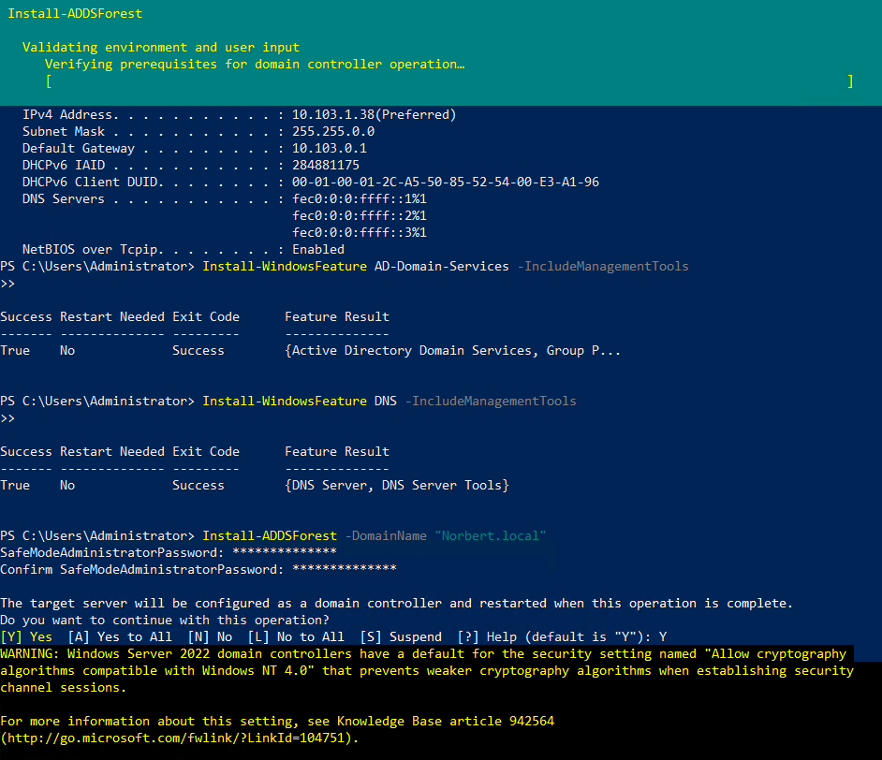

Zmenil som heslo lebo ma to promptlo ked sa restartovalo.

Zapisem si preistotu heslo sem: adm@PrBIT500??? (pridal som jeden otaznik)

**Úloha 3**

Organizacna struktura

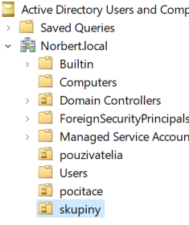

Novy user:

Heslo bolo rejectnute takze musime zistit password policy nasledovne(je to jednoduchsie cez powershell):

Heslo musi mat splnene aspon 3 z nasledovnych kategorii (ComplexityEnabled: True)  
uppercase, lowercase, cislo, specialny znak

MinPasswordLength: 7

PasswordHistoryCount: 24 (poslednych 24 hesiel nemoze byt zopakovanych)

MinPasswordAge: 1 (aspon jeden den ho nemozeme zmenit)

MaxPasswordAge: 42 (po 42 dnoch sa heslo musi zmenit)

Vyberieme si teda heslo: P@ssw0rd1

User bol vytvoreny

**Bonusova uloha**

Vytvoril som novy group policy object

Kliknutim na edit ideme zmenit veci

Komplexita hesla znamena ze heslo nemoze obsahovat meno pouzivatelovho uctu, alebo casti userovho celeho mena presahujuce dva za sebou iduce znaky, aspon 6 znakov dlhe, obsahuje znaky aspon z troch nasledovnych kategorii: uppercase, lowercase, cisla, specialne znaky.

Administrator account lockout sa nastavilo same

Na aplikovanie politiky pouzijeme: gpupdate /force

Tento prikaz nepotrebuje restartovat server, pretoze /force-ne novu politiku

Nastavenie minimalnej doby platnosti hesla zabranuje pouzuvatelom aby si okamzite niekolkokrat zmenili heslo a mohli tak opakovane pouzivat svoje stare heslo

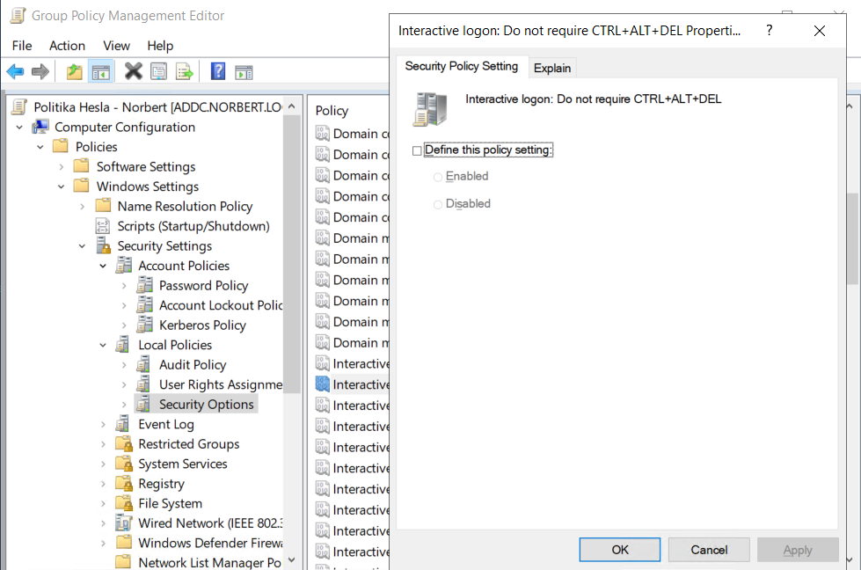

Pridava to vrstvu zabezpecenia. Zabezpecuje ze pouzivatelia pracuju s bezpecnou prihlasovacou obrazovkou Windows namiesto potencialne zlej prihlasovacej obrazovky